

Software Engineering Department
Braude - College of Engineering
Capstone Project Phase A – 61998

Pedagogical Training
Project code: 25-2-D-17
Supervisor:
Dr. Natali Levi-Soskin
natalyl@braude.ac.il

Authors:
Celin Asadi
celineassadi44@gmail.com
Anood Naem
alnoodnaim@gmail.com

Github link :

https://github.com/CelineAsadi/Pedagogical-Training-project.git

Abstract:
Classroom management remains one of the most significant challenges for early-career teachers, often leading to professional stress, burnout, and high attrition rates. Existing teacher education programs, while offering theoretical foundations, frequently fail to equip educators with practical tools for handling real-time behavioral disruptions. This project introduces an innovative pedagogical training system designed to bridge that gap through interactive, AI-powered classroom simulations. The system allows teachers to respond vocally to simulated student misbehavior in a virtual environment and receive immediate, personalized feedback based on speech analysis, emotional tone, and pedagogical intent. Using advanced natural language processing (NLP), machine learning, and real-time voice recognition, the platform evaluates the effectiveness of responses and tracks user progress over time. The goal is to enhance teachers’ confidence, communication skills, and readiness for real-world classroom dynamics. The system is designed for integration into teacher training programs, offering a scalable, research-based solution for improving classroom management capabilities.

Table of content :

Abstract: 2
1. Introduction: 4
2. Literature Review: 6
2.1 General Background: 6
2.2 Existing Tools for Addressing Discipline Problems: 6
2.3 The Need for an Innovative Solution – Bridging the Gap: 7
3.Expected Achievements: 9
3.1 Project Success Criteria: 9
3.1.1 Accuracy of Feedback Personalization: 9
3.1.2 Improvement in Performance Over Time: 10
3.1.3 User Satisfaction: 10
3.1.4 Institutional Adoption Potential: 10
4.Engineering Process: 10
4.1 Initial Phase: Identifying the Problem and Defining the Goal: 11
4.2 Research: Educational and Technical Basics for Simulation: 11
4.2.1 Prompt Engineering Process: 12
4.3 Design Alternatives and Final Solution: 15
5.Product: 15
5.1 Functional Requirements: 16
5.2 Non-Functional Requirements: 17
5.3 System Architecture: 17
5.4 Diagrams: 22
5.4.1 Use Case: 22
5.4.2 Class diagram: 23
5.4.3 Activity diagram : 23
5.5 Methodology and Development Process: 24
5.6 User interface: 24
6 Challenges and Constraints: 29
7. Verification: 30
8. References: 34

Introduction:
The contemporary education system is facing a critical and pressing challenge with regard to classroom management and student discipline. Many teachers, particularly those at the beginning of their careers, encounter persistent difficulties in their day-to-day work, such as constant student chatter during lessons, lack of attentiveness, frequent interpersonal conflicts among students, and even overt displays of disrespect toward the teacher’s authority. These disruptions not only interrupt the flow of instruction and hinder the learning environment, but also significantly diminish teachers’ sense of self-efficacy and, in some cases, contribute to their decision to leave the profession altogether.
Research indicates that approximately 30% of early-career teachers leave the profession within their first year, and nearly 50% exit within the first five years [5].One of the main reasons why new teachers leave the profession is the feeling of losing control when facing challenging behavior in the classroom, along with a lack of practical tools to handle it effectively. The transition from academic studies to daily classroom reality is often sudden and difficult. Teachers report a big gap between what they learned and what they actually experience, which leads to frustration and sometimes even professional burnout. According to research, burnout levels among new teachers are especially high, mainly due to constant behavior problems, lack of proper support, and a demanding environment.[4][7]
Although teacher education programs typically include content related to classroom management, many remain theoretical in nature and fail to reflect the complex and dynamic realities of today’s classrooms [5]. As demonstrated in studies of intensive residency programs for early-career teachers in the United States, such as the Resident Teacher Program, many new educators report feeling unprepared and insecure in their ability to manage classroom behavior—even after completing formal academic training. In many cases, they are left to develop these essential skills through trial and error, often at a significant emotional and professional cost [5].
Existing teacher preparation frameworks frequently fall short in equipping educators with effective, real-world solutions to behavioral challenges. As a result, many early-career teachers enter the classroom without the confidence or readiness required to face the multifaceted demands of classroom management from day one [12].
Several current approaches attempt to address classroom discipline within teacher education, including academic coursework, professional development workshops focused on authority and communication, classroom observations (which rarely expose candidates to severe or disruptive scenarios), and one-on-one mentoring—often centered more on administrative procedures than pedagogical decision-making. In addition, some technological platforms, such as SimSchool[10], offer personalized simulations, but these typically emphasize differentiated instruction rather than real-time behavioral intervention.
To bridge this critical gap,we intend to develop an innovative, interactive training system designed to provide practical skill-building in classroom management and behavior intervention.The system features a virtual classroom simulation and enables users to independently construct and customize their own classroom setup, providing a more personalized and immersive training experience.organize student groups, and deliver a lesson. During the lesson, various behavioral disruptions emerge—ranging from minor distractions to more serious behavioral challenges—requiring the teacher to respond using their judgment and instructional style. Upon completing the simulation, the system analyzes the teacher’s responses, evaluating the timing, appropriateness, and effectiveness of their actions. Immediate, personalized feedback is then provided, along with targeted suggestions for improvement.
The system will offer several key advantages: hands-on practice in a risk-free environment; realistic simulation of common and complex classroom scenarios; immediate, focused feedback; enhanced teacher confidence; and alignment with the developmental stages of students in grades 3 through 6. This tool is designed to support teacher trainees, early-career educators, experienced teachers seeking to refine their skills, and teacher training institutions. It provides a dynamic and immersive learning environment that fosters meaningful practice, strengthens classroom management competencies, reduces professional burnout, and enhances readiness for the real-world demands of education.
This document is structured as follows to present the full development process and pedagogical rationale behind the proposed system:Chapter 1 presents an overview of the challenges faced by beginner teachers in managing classroom behavior and introduces the motivation for developing a simulation-based training system. Chapter 2 reviews related work, including current teacher preparation methods and existing technological tools such as SimSchool. Chapter 3 outlines the project’s expected outcomes and success criteria, including the simulation environment, real-time feedback, and pedagogical decision-making support. Chapter 4 and 5 details the engineering process, covering problem analysis, system architecture, AI and NLP integration, and the rationale behind design decisions. Chapter 6 presents the main challenges in building the system, such as designing realistic classroom scenarios, integrating AI tools, handling natural language processing accurately, and ensuring ethical and user-friendly feedback. Chapter 7 discusses the evaluation plan, including methods for assessing feedback accuracy, measuring user improvement over time, and evaluating the system’s pedagogical effectiveness and institutional applicability.

2. Literature Review:

2.1 General Background:
Classroom discipline issues have become a central topic in educational discourse in recent years, with a marked increase in reports of recurring disruptions during lessons, conflicts among students, inattentiveness, and even open defiance of teacher authority.
Research indicates that such behavioral problems negatively affect the classroom climate, hinder the learning process, contribute to teacher burnout, and, in some cases, lead to attrition from the profession [8].

2.2 Existing Tools for Addressing Discipline Problems:
Various tools have been developed to help teachers address discipline-related challenges, yet each has its own limitations. Most teacher education programs begin with theoretical coursework in classroom management. These courses include academic readings, case analyses, and pedagogical models that aim to introduce future teachers to core concepts such as conflict resolution, classroom routines, and the application of positive reinforcement. While this type of training provides a solid research-based foundation, it rarely extends into real-world scenarios. In Israel specifically, such training often includes only a few weeks of hands-on experience per semester, without structured or ongoing practical guidance. As a result, many early-career teachers report feeling unprepared to handle disruptive behavior once they enter the classroom.[4] [5].

To address the lack of applied practice in theoretical programs, professional development workshops are offered to both early-career and experienced teachers. These sessions are typically more hands-on, focusing on classroom authority, managing challenging behavior, and leading discussions. They are facilitated by experienced educators and often include role-play or guided simulations. Unlike theoretical programs, these workshops allow teachers to actively engage with real classroom situations. However, they are often limited in depth and follow-up. For example, the induction-year seminar in Israel—a key part of many teachers' first year—is frequently criticized for being overly theoretical itself. Moreover, while teachers are required to complete 30 hours of professional development annually, many choose workshops unrelated to discipline, limiting their practical impact. Additionally, most workshops lack mentoring components or personalized feedback, making it difficult for participants to internalize and apply what they learn over time [12].

While both academic programs and workshops offer structured learning opportunities, they often fail to provide personalized, in-situ guidance. This gap is partially addressed through pedagogical mentorship and classroom observations, in which experienced educators observe early-career teachers, provide feedback, and sometimes model behavior management strategies. Unlike prior methods, mentorship offers real-time, context-specific support that can directly influence classroom practices. However, this form of guidance is often limited in frequency—usually to only one or two observations per semester—and rarely includes complex behavioral dynamics or nonverbal cues. Furthermore, feedback is typically delayed, and mentoring often starts only after formal observations are complete. In some cases, the presence of an observer in the classroom may actually heighten stress for early-career teachers, causing them to feel judged and perform less authentically[5].

In response to the limitations of live mentoring, technological solutions such as SimSchool have emerged. SimSchool is a simulation platform that allows teachers to experiment with classroom scenarios based on diverse student profiles, providing performance feedback in a low-stakes, virtual environment. Unlike mentorship or workshops, SimSchool enables repeated practice and experimentation without fear of judgment. It also offers a degree of personalization and feedback that is not always present in traditional programs. However, it has its own limitations. The platform is not widely used in Israeli teacher education programs, and its main focus is on instructional adaptation rather than behavior management. Therefore, while it provides a valuable space for learning differentiation strategies, it does not fully address the emotional and situational complexity of real-time classroom discipline[10][13].

In summary, although each of these tools contributes important components to teacher preparation, none offers a comprehensive and practical solution for managing disruptive behavior in the classroom. This highlights the need for an integrated system that combines realistic practice, targeted feedback, and emotional readiness—all within a safe and supportive learning environment[13][5].

2.3 The Need for an Innovative Solution – Bridging the Gap:
Recent studies emphasize the critical importance of experiential learning models in teacher training – highlighting active engagement, trial and error, immediate feedback, and continuous improvement of teaching skills. However, most current training programs are predominantly theoretical, offering limited exposure to practical simulations or complex educational scenarios[3].
A platform simulating a virtual classroom with real-time disruptions would allow teachers to practice diverse responses, receive precise performance analytics, and benefit from personalized feedback – thus bridging the gap between theoretical training and classroom realities. This kind of practice contributes to the development of teachers' self-efficacy and reduces feelings of helplessness in the face of disciplinary challenges [3].
These findings match the study by Cohen-Azaria (2021), which shows that many teachers in Israel feel frustrated and unsure of themselves when facing discipline problems in the classroom – mainly because they haven’t received enough practical training. The lack of effective classroom management tools leads to stress, burnout, and a feeling of losing control, highlighting the need for hands-on training that focuses on dealing with student behavior [2].
Furthermore, effective professional development must include active participation, accurate feedback, and ongoing evaluation – components that are often absent from the current available tools. Interactive systems incorporating realistic simulations, real-time interventions, and personalized performance reports could offer tailored and effective solutions for each teacher – aligned with their experience level, instructional style, and individual needs.
In addition, classrooms in Israel face unique challenges related to the character of local students – such as strong emotional expression, direct ways of speaking, and a cultural tendency to question the teacher’s authority. Along with diverse cultural backgrounds and national stress factors, all of this shows how important it is to develop customized solutions that realistically simulate the Israeli classroom environment [2].
Moreover, while existing technologies such as SimSchool offer notable advantages in instructional differentiation, research suggests they fall short in addressing classroom disruptions or complex emotional responses by teachers [6]. This underscores the clear need for a dynamic, innovative, and multidimensional solution.

3.Expected Achievements:
This project aims to bridge the persistent gap between theoretical teacher training and the complex, dynamic realities of actual classroom management. By developing an interactive simulation environment, the project seeks to provide pre-service and in-service teachers with a safe, realistic platform for practicing responses to challenging behavior scenarios, accompanied by tailored feedback.

3.1 Project Success Criteria:
To evaluate the impact and effectiveness of the system, the following success criteria will be defined:

3.1.1 Accuracy of Feedback Personalization:
The system is required to provide feedback that is tailored to the user’s individual teaching style, based on accurate analysis of their performance.
One of the defined success metrics is the percentage of users reporting that the feedback they received was relevant and personalized.
This metric will be evaluated using digital questionnaires completed at the end of each simulation session, where users will be asked to rate the level of personalization on a Likert scale.
A target of at least 85% satisfaction with personalized feedback has been set.
Satisfaction will be calculated based on the percentage of respondents who select "very satisfied" or "completely satisfied" in the survey.
The choice of this target is based on standard benchmarks for measuring customer satisfaction, where a score between 75% and 85% is considered very good and indicates a high level of satisfaction [11].
This benchmark is grounded in previous studies and industry standards for digital educational systems.
In addition, studies on the usability of e-learning platforms have shown that satisfaction rates between 80% and 85% reflect high system effectiveness [14].
In such cases, the system will also analyze actual user behavior patterns (such as time spent, number of interactions, and response to feedback) to validate the findings.
Furthermore, research on adaptive learning systems highlights the wide variety of teaching styles and personal preferences—making perfect satisfaction scores unrealistic [1].
Therefore, users will be given the option to provide open-ended comments in the questionnaire, allowing them to express their perceived level of personalization or suggest areas for improvement.
Thus, setting the target at 85% reflects a goal of high effectiveness while maintaining realism, taking into account the natural variation in user experiences and instructional preferences.

3.1.2 Improvement in Performance Over Time:
The system must enable users to track and improve their responses through repeated exposure. The defined success metric is an improvement of at least 20% in both reaction time and response quality across simulations. This threshold was selected as a measurable and realistic indicator of progress that reflects meaningful user development over multiple sessions. The system will measure this improvement by comparing users’ average reaction times and response ratings between initial and subsequent simulation attempts, using built-in performance analytics already planned as part of the platform's feedback mechanism.

3.1.3 User Satisfaction:
The system must offer a clear, realistic, and empowering experience for all users.
Success metric: At least 90% of users will report a positive experience in terms of usability and professional confidence.

3.1.4 Institutional Adoption Potential:
The system should demonstrate potential for integration into formal teacher training programs.
Success metric: At least one teacher education institution or educational body will conduct a pilot and express interest in ongoing adoption.

4.Engineering Process:
This is the main part of our project. It will explain how we will build the system from the beginning to the end . We will begin by understanding the problem we're solving and what the system needs to do. Then, we will plan, design, build, test the system to evaluate how well it performs. We will also discuss any challenges or limitations we may encounter. This section will demonstrate how we progress logically throughout the development process, focusing on thoughtful, educational, and technically sound decisions.

4.1 Initial Phase: Identifying the Problem and Defining the Goal:
First, we will clearly identify a big problem: new teachers often start teaching without enough practice managing a classroom or handling student disruptions right away. This lack of experience can make them avoid dealing with problems or overreact because they're stressed or unsure. Moreover, many new teachers struggle to understand the difference between various types of misbehavior – such as seeking attention as opposed to displaying mere stubbornness – which can lead to unhelpful ways of responding. To fix this, our project will create an interactive simulation. This simulation will show realistic classroom situations and let teachers record how they react in real-time. The system will then give them personalized advice that matches their communication style and teaching approach, helping them practice in a safe and controlled space.

4.2 Research: Educational and Technical Basics for Simulation:
As part of this project, where we aim to build an interactive simulation to help teachers with discipline, we conducted extensive research to inform our design.
We sought to understand key issues such as:
- What are the biggest challenges new teachers will face in classrooms today?
- What are the most common disruptive behaviors in elementary schools (grades 3-6), and how do they usually appear in class?
- What early signs might show a teacher is struggling to control the class, and how will that affect learning?
- How much practical advice does current teacher training give for handling behavior issues?
- What teaching styles (like being firm, educational, or working with students) are considered most effective, and how do they change?
- Will teachers tend to just react to problems instead of having a plan for behavior?
- How will lack of real experience affect new teachers' confidence, and is it linked to them getting tired of teaching or leaving the job?
- What technology is currently available to train teachers in classroom management, and does it handle real-time emotions and behaviors well?
- Can teacher reactions be modeled and studied in an educational way to see if they are effective?
- How can we design a system that gives personalized feedback that makes teachers more aware and helps them manage lively classrooms?
To answer these educational questions and better understand the challenges new teachers will face, we reviewed academic papers, educational reports, interviewed teachers, consulted experts, and examined both local and international research. Based on the insights gathered, we formulated key design principles for our system. We focused on students aged 8–12 (grades 3–6), as this age range commonly exhibits manageable yet meaningful behavior challenges, such as inattention, peer conflicts, noncompliance, social withdrawal, and emotional outbursts.
Our simulation goes beyond verbal responses, evaluating subtle communication cues such as tone of voice, response timing, assertiveness, and the ability to balance strictness with empathy. The system encourages reflection by allowing teachers to learn from both successful and less effective responses, comparing them to examples of effective teaching practices in order to support professional growth.

4.2.1 Prompt Engineering Process:
As part of our initial development phase, we experimented with different prompts—custom instructions given to the AI—to evaluate teacher responses to classroom scenarios. The goal was to determine which prompt structure would produce feedback that is not only accurate, but also pedagogically useful, constructive, and aligned with real-world teaching challenges .
First Prompt (Rejected):
"Evaluate the teacher’s response grammatically and provide feedback about language and tone. Rate the sentence from 1–10 and suggest improvements."
Example Teacher Response:
“I know you’re upset, but yelling is not okay. Let’s take a break.”
AI Output:
“This sentence is informal. Consider rephrasing to: ‘I understand your frustration, but raising your voice is inappropriate. Please take a short break.’ Score: 6/10.”
Why it failed:
- The AI focused mainly on grammar and formal phrasing, overlooking the emotional intelligence demonstrated in the original response.
- It penalized informal but natural and empathetic language.
- The feedback was generic and disconnected from the classroom context.
- It made no reference to whether the response was effective in managing student behavior.
Conclusion:
This prompt consistently generated linguistically-focused feedback with little pedagogical value. It was rejected as misaligned with the simulation’s educational goals.
Second Attempt (Partially Effective):
After observing that the first prompt prioritized grammar over pedagogy, we adjusted the prompt to focus more on teaching intent and emotional tone.
Prompt:
“Evaluate whether the teacher’s response achieves its pedagogical goal. Consider clarity, emotional tone, and suitability to the student’s behavior,and give a score out of 10 ”
Example Teacher Response:
“That’s not how we treat others. Please apologize and take a seat.”
AI Output:
“The teacher provides a firm and respectful correction. The message is clear and appropriate. However, tone analysis suggests the response might lack warmth. Consider softening the tone slightly. Score: 7.5/10.”
What Improved:
- The AI considered intent and tone more meaningfully.
- It recognized clear behavioral boundaries and encouraged improvement.
- Feedback became more context-aware.
Remaining Limitations:
- The analysis of emotional tone was sometimes inconsistent.
- Suggestions still leaned on surface-level phrasing instead of deeper behavioral strategies.
Conclusion:
This prompt marked significant progress, but lacked structured evaluation criteria and consistency across varied responses. It led us to further refine our approach toward a more weighted and context-sensitive evaluation.
Final Selected Prompt :
After iterating on the previous designs, we developed a refined prompt focused on pedagogical effectiveness, emotional intelligence, and contextual appropriateness. This version introduced clear evaluation components and specific weights for each.
The weighted rubric was refined with input from a pedagogical advisor over multiple sessions, ensuring that each scoring dimension accurately reflects its real-world importance.
Final Prompt:
“You are a pedagogical evaluator helping teachers improve classroom management. You will receive a verbal response from a teacher to a simulated student disruption. Please evaluate the teacher’s pedagogical intent, tone, and contextual appropriateness. Do not penalize for informal language, grammatical mistakes, or casual tone. Focus on whether the teacher’s response:
- Demonstrates authority and emotional intelligence
- Matches the severity and nature of the student’s behavior
- Supports a respectful and inclusive classroom climate
- Encourages behavioral improvement
your response should include:
- A numerical score from 1–100 (reflecting overall pedagogical quality), calculated based on the following weighted components :
  - Response Timing (6%): How fast the teacher reacts to the student’s behavior.
  - Emotional Tone (18%): Based on voice analysis (e.g., pitch, loudness, speaking speed, pauses).
  - Intent and Content (40%): Analysis of what the teacher meant and if the response fits recommended classroom management strategies.
  - Language Appropriateness (16%): Checks for clear teaching language, correct terms, and encouraging words.
  - Overall Consistency (20%): Measures if the teacher maintains a consistent teaching style across different situations.
- A short narrative explanation: What was done well, and why
- One or two constructive suggestions for improvement, if needed
The evaluation should be professional, encouraging, and growth-oriented. This prompt was carefully selected after testing alternatives that overly emphasized grammar or formality, leading to non-pedagogical feedback. “
Rationale for Selection:
This prompt prioritizes emotional intelligence, intent, and contextual fit—principles consistent with positive discipline, teacher autonomy, and a supportive classroom climate. It shifts the AI from a linguistic critic to a constructive coach.

4.3 Design Alternatives and Final Solution:
During the development process, we explored multiple approaches for implementing the simulation interface. Each option was evaluated in terms of pedagogical effectiveness, technical feasibility, and alignment with the project’s scope and constraints:
- Multiple-choice interaction was the simplest to implement, but it restricted teachers to a predefined set of responses and did not allow for authentic speaking practice.
- Text-based interaction made natural language processing (NLP) easier to handle but failed to simulate realistic classroom conditions, as teachers do not type their responses during real-time interactions.
- Virtual Reality (VR) provided a highly immersive and realistic experience but introduced significant technical complexity, high development costs, and accessibility issues, making it impractical for our current project scope.
After comparing the alternatives, we selected an open-ended voice response simulation combined with NLP-based analysis. This approach allows teachers to respond naturally and verbally, closely mimicking real classroom scenarios. It also enables the system to analyze the teacher's speech in depth—including emotional tone, pedagogical intent, and teaching style—while supporting real-time decision-making and emotional regulation practice.This solution offers the best balance between pedagogical value, technical feasibility, and project constraints .

5.Product:
The product is an interactive AI-based platform that allows teachers to practice classroom management in a realistic, voice-driven simulation. The system features a predefined baseline classroom with 32 students, a 40-minute lesson, and a diverse set of behavioral profiles:
- 7 students with attention difficulties
- 5 who speak without permission
- 4 who show resistance or defiance
- 3 who are emotionally sensitive
- 2 who are socially withdrawn
- 3 involved in interpersonal conflicts
- 2 sarcastic or passive-aggressive students
- 2 hyperactive students
- 4 neutral students who do not cause disruptions
This group setup was designed based on classroom observations and consultations with educational experts. The distribution reflects the relative frequency of these behaviors in real-world elementary schools. More common challenges—such as inattention, impulsive speech, and off-task behavior—are represented more heavily. Less frequent issues—such as emotional sensitivity, defiance, peer conflicts, and social withdrawal—are included in moderation. Sarcastic, hyperactive, and neutral students round out the class to provide a balanced, realistic environment where teachers can experience a variety of scenarios.
In each simulation, the AI engine (powered by GPT) selects which students will present behavioral challenges, based on the teaching context and the teacher’s real-time responses. This dynamic selection ensures a wide range of practice opportunities and reflective learning experiences.
Alternatively, users can customize their classroom by choosing disruption types, the number of students (20–32), and lesson duration (20–40 minutes).
During system registration, a user profile is created, including teaching experience, pedagogical style, and emotional approach. This profile guides the algorithm in tailoring scenarios, determining disruption types, and timing their appearance. The AI engine dynamically controls in-class disruptions based on virtual student profiles, the teacher's profile, and their in-simulation responses.
Student behavior adapts dynamically to the teacher's reactions, considering content, tone of voice, and overall style. For instance, a calm and empathetic response may reduce disruptions, while a harsh or inconsistent reaction could escalate them.
At the end of each simulation, users receive comprehensive feedback, including positive reinforcement, areas for improvement, final score (0–100), and a visual graph comparing current performance to previous sessions. This enables users to monitor progress and gain practical insights for improving classroom management skills.

5.1 Functional Requirements:
- The system enables users to practice responses to classroom behavior disruptions in a virtual classroom environment.
- The system presents classroom scenarios using both audio and text formats.
- The system captures free-form voice responses from the user (no typing required).
- The system converts spoken responses into text using a speech recognition engine.
- The system analyzes the transcribed text for pedagogical intent, emotional tone, speaking style, and response timing.
- The system performs emotional analysis of voice input.
- The system uses AI-based models (GPT) to interpret the meaning and pedagogical appropriateness of the user’s response.
- The system provides immediate and personalized feedback, including strengths, improvement areas, and alignment with pedagogical models.
- The system stores user responses and performance scores in a personal history log to enable progress tracking over time.
- The system allows users to configure the virtual classroom, including number of students, seating arrangement, and student behavior types.
- The system includes a demo mode where voice responses are processed but not stored in the database.
- The system highlights important words and tone markers in real time through live transcription.
- The system processes the response and displays the simulation results after the lesson is over.
- The system allows users to review their responses and scenarios after feedback, to improve and start a new session.

5.2 Non-Functional Requirements:
- Simple and intuitive user interface.
- Accurate voice recognition even with accents and background noise.
- Fast response time – processing occurs within seconds.
- Data security – no voice recordings are permanently stored.
- Support for Hebrew, English, and Arabic.
- Full 24/7 system availability.
- Scalability – supports multiple users simultaneously.
- Support for updating AI models and adding new scenarios.
- Transparent analysis – users receive clear explanations of feedback.
- Stability and reliability even under high usage load.

5.3 System Architecture:
We implemented a client-server architecture to ensure clear separation between the user interface and the system’s processing logic. This structure enables the client side (browser application) to handle user interactions like scenario selection and voice input, while the server side manages data processing, integrates AI services, and generates feedback.
This approach supports real-time communication between the client and backend via HTTP, enhances system security by isolating sensitive processing on the server, and allows for scalability to support multiple concurrent users. Furthermore, it facilitates system maintenance and future expansion, such as incorporating user authentication, tracking user progress, or adding new behavioral scenarios.
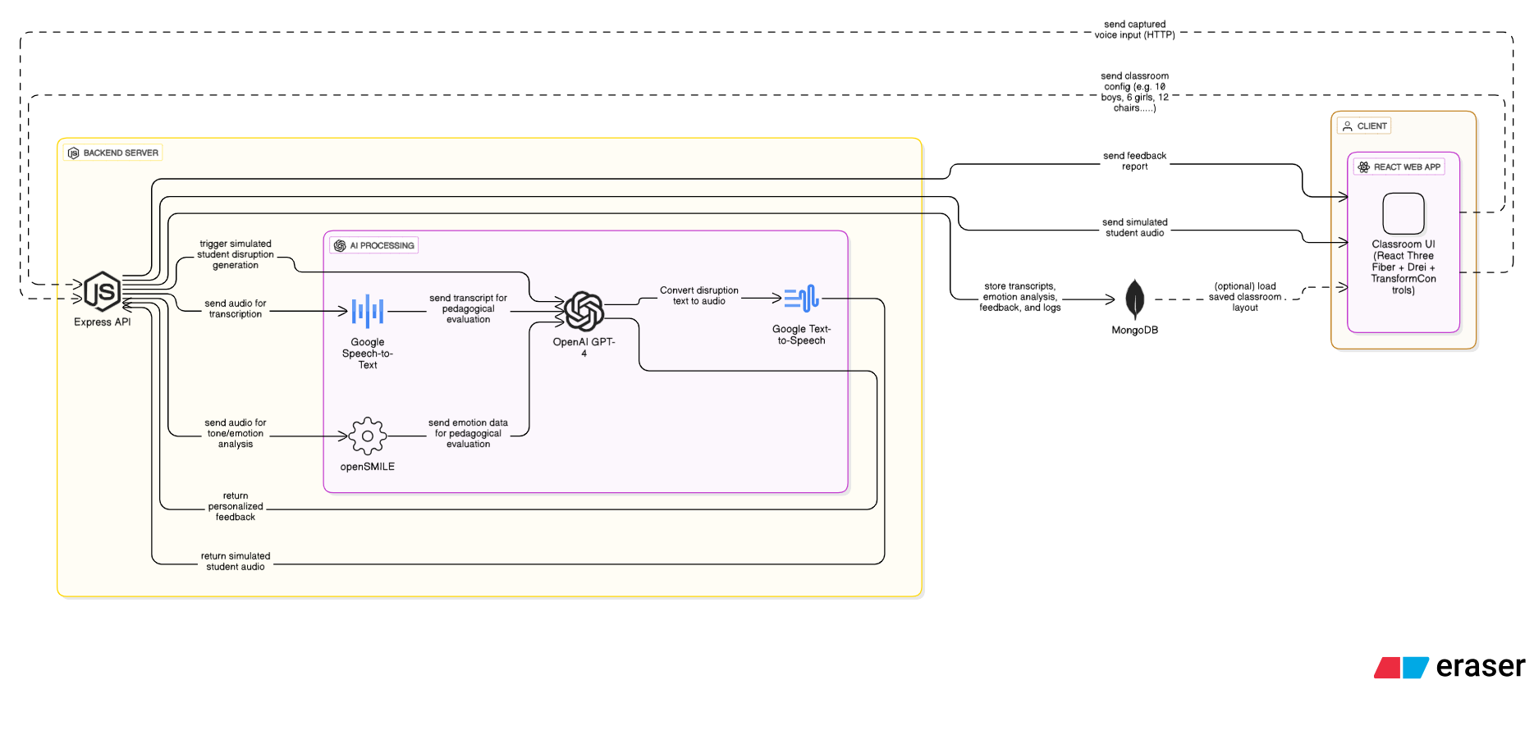
Figure 1: Architecture scheme
Client Side – (Frontend):
For the client side, we selected the React.js library, a popular and powerful tool for modern web interfaces. React was chosen for its component-based architecture, which allows each UI element—such as a virtual student, error message, or scenario menu—to be managed as an independent unit with its own logic and style.
React also supports fast and smooth rendering through its Virtual DOM, ensuring an optimized user experience even during frequent UI updates. Additionally, React includes modern development tools like Hooks for state management and Context for data sharing between components, enabling real-time sharing of voice analysis or evaluation results across all relevant interface elements.
Server Side -(Backend):
The server side of the application is built using Node.js and Express.js. Node.js enables JavaScript code execution on the server side, allowing for a unified language across both frontend and backend. Express.js adds a lightweight and flexible API layer that efficiently handles operations such as sending and receiving audio files, transcriptions, and NLP-processed data.
The backend supports asynchronous event handling, essential for managing concurrent voice file processing, classroom interactions, and GPT-based analysis. Node.js is also well-suited for real-time communication, and can be extended with tools like Socket.io to provide immediate feedback and interaction—for example, playing an audio-based classroom interruption or triggering real-time system responses.
Virtual Classroom Construction:
The virtual classroom was developed as an interactive 3D simulation that realistically represents a school environment with movable desks and student avatars. We chose React Three Fiber, a React renderer for Three.js, to seamlessly integrate 3D graphics within our React frontend, enabling efficient rendering and state management. The base 3D engine, Three.js, was selected for its robustness and flexibility in handling complex 3D scenes. To enhance development speed and user interaction, we integrated the Drei library, which provides ready-made components such as TransformControls to allow users to intuitively move and rearrange desks and students. Student models were designed using simple geometric shapes to balance visual clarity and performance, ensuring smooth operation even on standard web browsers. This setup provides an immersive, dynamic classroom environment, supporting the project’s goal to create realistic and interactive training for teachers.
Disruption Generation Mechanism :
Student disruptions within the simulation are triggered through a mechanism known as the Behavior Engine. Each virtual student in the system is pre-defined with a unique behavioral profile (e.g., mischievous, sarcastic, shy, or angry), along with corresponding types of disruptive behaviors. When the teacher responds or a classroom scenario unfolds, the engine dynamically selects which student will react, based on a combination of the teacher’s profile (e.g., assertive, calm) and the current classroom interaction.
The disruptive content is generated dynamically, simulating natural student speech (e.g., “What might a bored 11-year-old say in class?”). To create such realistic utterances, the system employs the GPT-4 language model, which was chosen for its high contextual understanding, ability to produce varied and natural expressions, and ease of integration via API. GPT-4 enables the generation of contextually appropriate and realistic responses that align with evolving scenarios and individual student profiles, thereby enhancing the authenticity and precision of the simulation.
The generated text is then converted into speech using Google Text-to-Speech, selected for its high-quality voice output, multilingual support, and seamless integration capabilities. The resulting audio file is played on the client side next to the corresponding student avatar, creating an immersive and pedagogically meaningful classroom experience.
Speech and Text Processing Module:
Once the teacher speaks, the audio file is sent to the server and undergoes two main processing stages:
Stage 1: Emotional Speech Analysis
The system segments the speech signal into short frames (10–25 milliseconds) and extracts prosodic features such as pitch, loudness, speech rate (via syllable count), and pause patterns. These features are passed through a dedicated neural network that identifies the emotional tone conveyed—such as happiness, anger, frustration, or empathy. The output of this process is a primary emotional tag, which is used in subsequent analysis stages.
The tool openSMILE was selected for this stage due to its high accuracy in detecting emotional acoustic features, real-time processing support, and status as an industry-standard framework. Its fast feature extraction and seamless integration with machine learning pipelines make it particularly suitable for real-time pedagogical applications.
Stage 2: Speech-to-Text Conversion
The system converts speech into written text using Google Speech-to-Text, employing an acoustic model for phoneme recognition and a language model to construct grammatically and semantically coherent sentences. This stage performs no emotional or content-based analysis—only accurate transcription. Google STT was chosen for its high recognition accuracy, multilingual support (including Hebrew, Arabic, and English), and suitability for real-time processing.
NLP Module:
To enable pedagogical analysis of the teacher’s responses, the system integrates the OpenAI GPT-4 language model via API calls from the backend. The Node.js server is responsible for transmitting the transcribed text and extracted vocal features to the GPT-4 model, which returns a structured analysis and personalized feedback. This integration is implemented as a core component of the backend logic, leveraging asynchronous communication and real-time processing capabilities. The selection of GPT-4 was based on its high contextual accuracy, seamless API integration, and strong suitability for dynamic, education-oriented environments.
Evaluation Engine:
To provide accurate and pedagogically meaningful feedback, the system includes an evaluation engine that receives the disruption data and the teacher’s analyzed response. These are sent to the GPT model along with a custom-designed prompt. GPT then returns a numerical score (on a scale of 1–100), a brief pedagogical analysis, and a personalized improvement suggestion.
This engine is powered by the OpenAI API and was chosen for its ability to process complex classroom scenarios, generate meaningful recommendations, and function as a virtual coach to help teachers develop more effective classroom management strategies.

Database: All data collected during the simulation—including the triggered disruption, student identity, teacher response, transcription, analysis results, and evaluation output—is stored in a MongoDB database.
MongoDB was selected for its flexible document-oriented structure, native support for JSON formats, and scalability as the data structure evolves. Its seamless integration with Node.js ensures high performance, efficient querying, and the ability to conduct retrospective analytics on teacher sessions.

5.4 Diagrams:

5.4.1 Use Case:
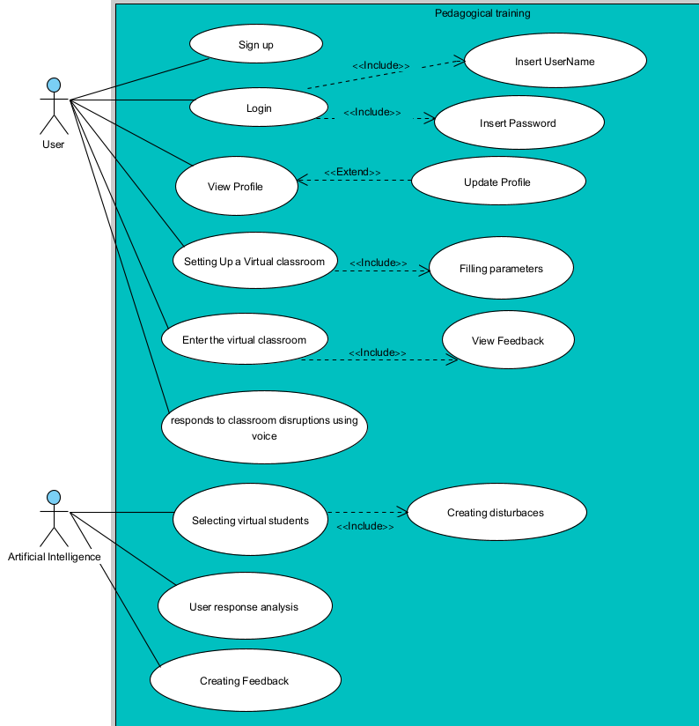

5.4.2 Class diagram:

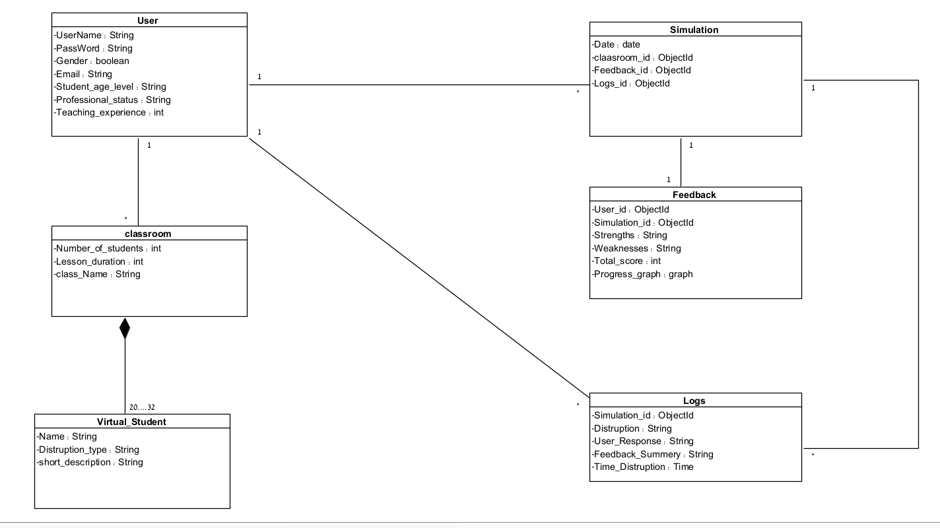5.4.3 Activity diagram :

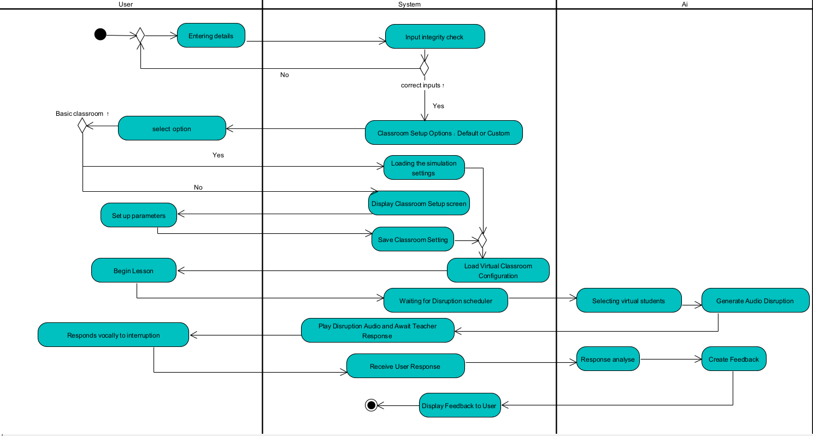

5.5 Methodology and Development Process:
We will build the system using the Agile method. This method is perfect for this project because it's interactive and always changing. We will work in short, repeating "sprints" (work cycles). In each sprint, we will focus on building, testing, and improving one specific part of the system, based on feedback from users. This way, we will be able to combine new technology with good teaching ideas, while staying flexible to make needed changes and add more features. For project coordination, we will have two meetings every week and detailed reviews at the end of each development cycle.

5.6 User interface:
The home page is clean and minimalistic, allowing new teachers to navigate the platform with ease and without distractions.
Upon entering the page, the user is presented with an introductory video that explains how to use the system.
This layout ensures a smooth onboarding experience, even for users with limited technical background.
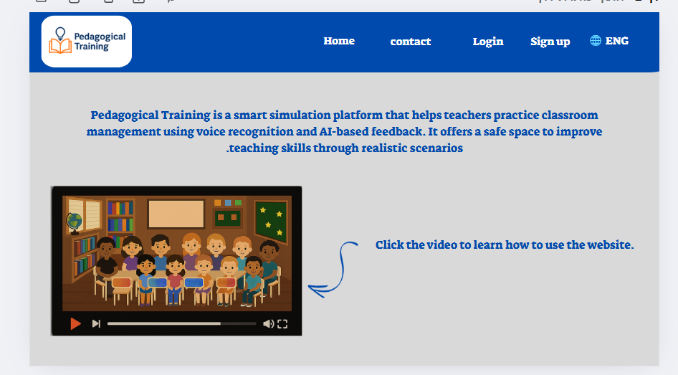  Figure 2: Home page | If the user clicks “Login” on the home page, it means they have already used the system. This screen prompts them to enter their username and password to access their personal training space.
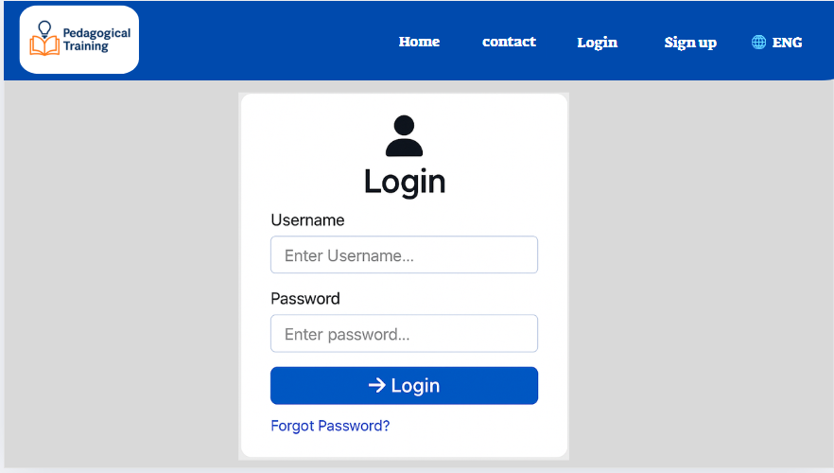  Figure 3: Login page | After a successful login, the user is taken to a central screen offering the main options of the system:  Start a basic simulation, set up a customized class, update profile, view past simulations, change language, contact support, logout, or return to the home page.
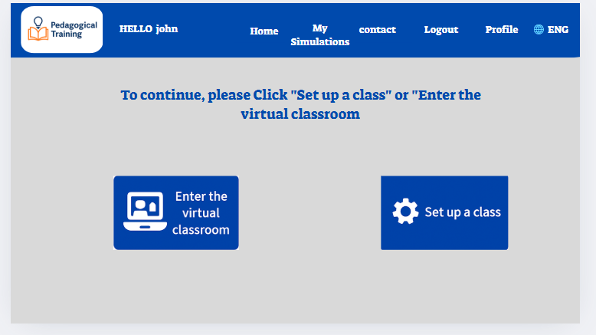  Figure 4: Main Menu page | By clicking “Profile,” the user can access and update their personal details, such as name, email, and language preferences.
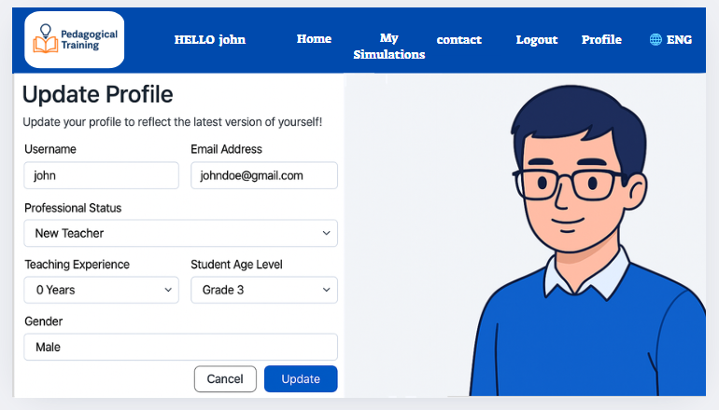  Figure 5: Profile page | By clicking “ contact” the users can reach out to the support team through a contact form, and also show email, phone, and location details.
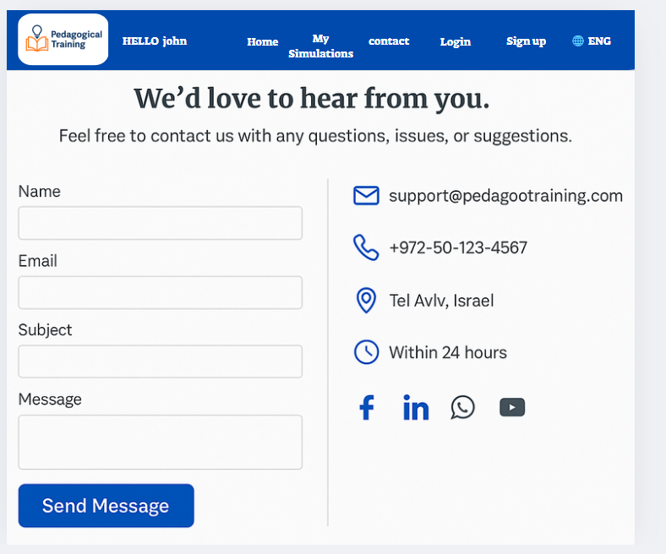  Figure 6: Contact page | By clicking “My Simulations” displays a list of all simulations the user has completed.  Each row includes buttons to view the full feedback and access the detailed log of that session.
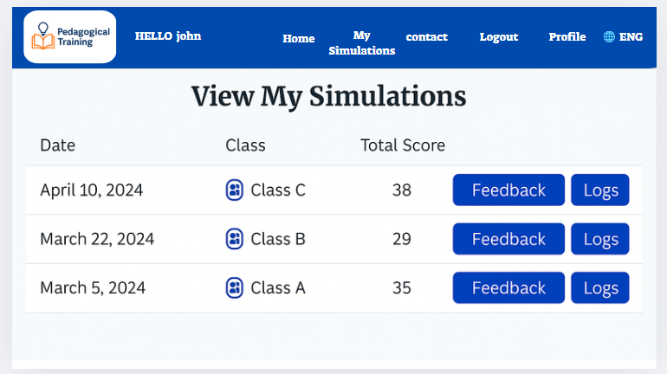  Figure 7: My Simulations page | By clicking “Feedback” opens a detailed analysis of a specific simulation, including strengths, areas for improvement, progress chart, and a total performance score.
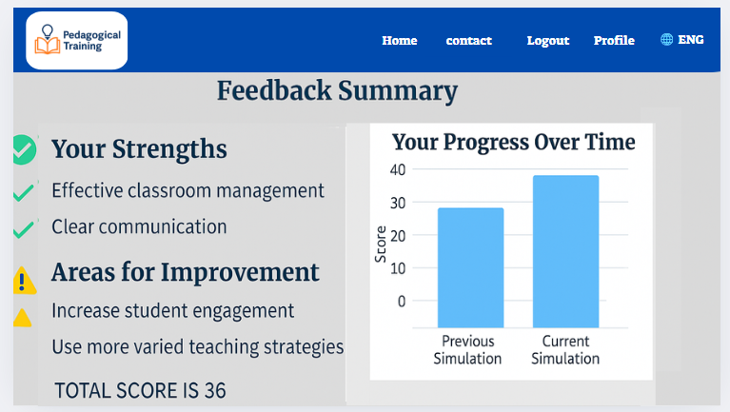  Figure 8: Feedback page | By clicking “Log” opens a record of the simulation session, showing the disruptions triggered, the user’s voice responses, emotional analysis, and response timing.
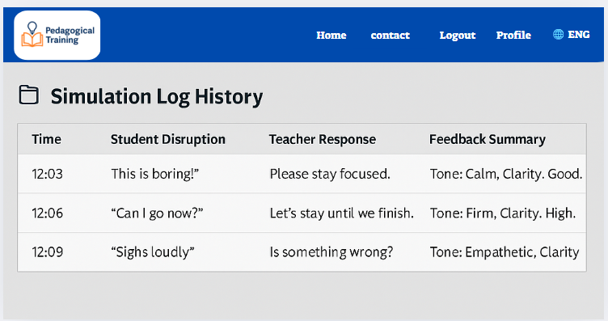  Figure 9: Log page | By clicking the “Set Up a Class” option allows the user to customize simulation parameters such as number of students, types of disruptions,lesson duration.
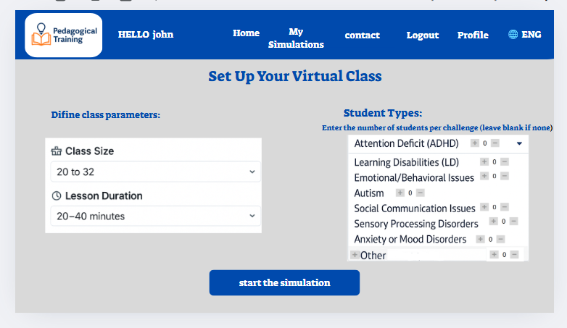  Figure 10: Set up class page | Once a simulation starts, the user enters the virtual classroom.  An AI-driven student disruption is played, and the user responds vocally. The system analyzes the response in real time.(this screen also shows up by clicking on “Enter the virtual classroom”).
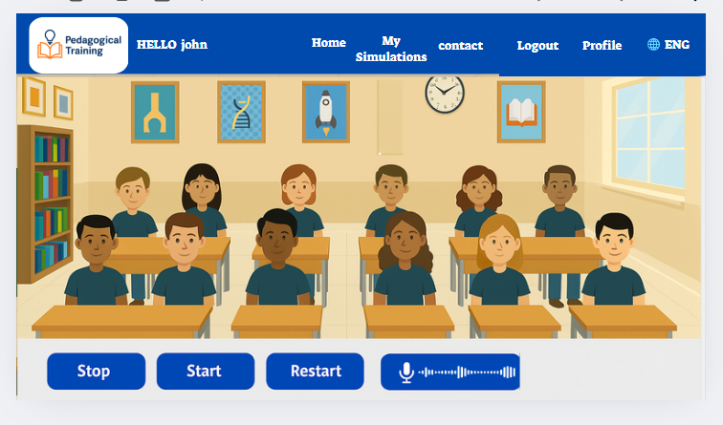  Figure 11: Virtual classroom page | After the simulation ends, a summary screen pops up, displaying performance charts, the overall score, and personalized improvement suggestions.
  Figure 12: Feedback page | If the user forgets their password, they can click “Forgot Password” on the login screen. This will open a recovery screen where they can reset their credentials.then the user is directed to the main options interface – Figure 4: Main Menu page is displayed.
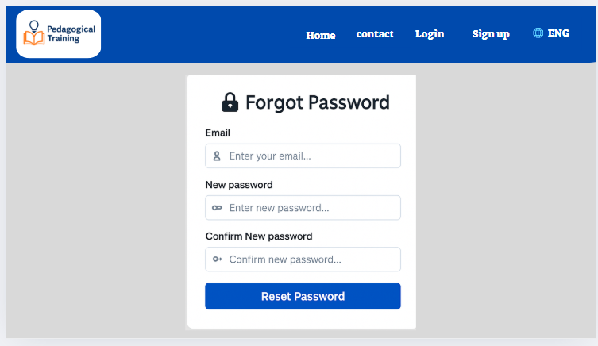  Figure 13: Forgot password page | If the user is new, they can click “Sign Up” on the home page screen. This will open the registration screen where they can create a new account.
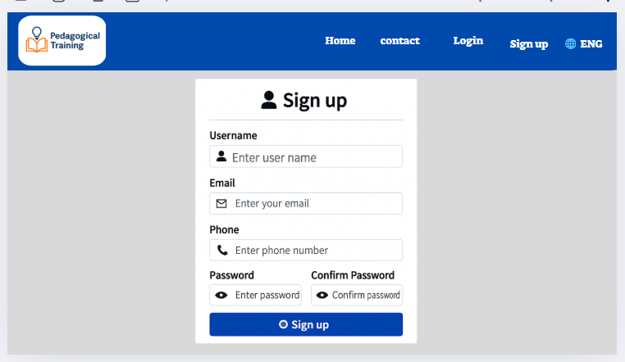  Figure 14: Sign up page | After signing up for the first time, this screen appears to help personalize the user's experience. The user is asked to complete a short form with their gender, professional status, teaching experience, and student age level before continuing.
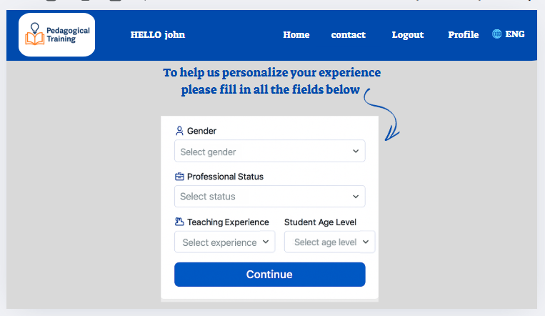  Figure 15: Personalization Form page | then the user is directed to the main options interface – Figure 4: Main Menu page is displayed.

6 Challenges and Constraints:
While building the system, we will need to deal with some important problems that will affect our decisions and how we design the system. These problems can be split into three main types:
1. General System Design Problems:The main problems here will be balancing how real the classroom situations feel with what we can actually build with technology. We will need to create a way to recognize and understand teachers' spoken answers (not just multiple-choice), and still be able to understand them and give useful feedback. Also, we will need to create a fair way to judge how effective a teacher's responses are, including things like how fast they respond, their language, and their teaching tone. Another problem will be understanding small voice details – like tone, speed, and how firm someone is – in a way that's important for teaching, especially since we won't have video. We will focus on computer programs that can pull out and judge these voice clues.
2. AI Integration Problems:We will face the "black box" problem with AI models, meaning it's hard to see how they make decisions. So, we will try to provide written reasons that explain how the teacher’s responses affect their evaluation score. The problem will also include smoothly connecting the voice analysis part with the user interface, how scenarios play out, and the reporting system. We will need to make it work well to avoid delays or errors. We will also need to make the AI parts strong enough to be used all the time and handle many users. Plus, we will develop a clear and easy-to-use interface that will work even for people who aren't tech-savvy. A big problem will be combining voice data (emotion, tone) with text analysis (what was meant, style) to make sure the feedback is consistent and makes sense for the situation. We will constantly consult and work with education experts to ensure this.
3. Natural Language Processing (NLP) Problems:In NLP, we will face the problem of losing emotional information when voice becomes text, which could change the meaning (for example, a supportive comment might sound harsh). We will build a system that analyzes the voice input before it's written down to catch emotional and non-verbal elements. We will also deal with speech recognition errors (from background noise, fast talking, or accents), and will use advanced computer programs to make it more accurate. The system will need special adjustments to understand educational context and language subtleties (humor, sarcasm), because general NLP systems don't always get these right. We will understand that teachers have different communication styles (firm, understanding), and will design flexible evaluation models. We will handle possible biases in AI models (like GPT or BERT) by creating detailed instructions (prompts) that will guide the model to understand teaching goals. Finally, we will pay attention to privacy and ethics (no storing recordings, anonymous and secure processing) and will make sure the feedback is supportive, not judgmental, focusing on strengths and ways to improve.

7. Verification:
Verification involves ensuring that the system functions as intended across all technical and performance aspects, including speech input, backend processing, and output generation. This process is conducted iteratively throughout development.
Unit Testing:
Individual system components are tested independently:
- Emotion detection engine: Accurately classifies voice tone (e.g., angry, calm).
- Text analysis engine: Correctly identifies sentence types (e.g., question, instruction).
- Simulation engine: Accurately triggers classroom scenarios and responds to user input.
Integration Testing:
These tests examine whether different modules work seamlessly together:
- Speech input is correctly routed to the AI engine.
- The returned result is further processed and displayed appropriately.
- Tools like Postman are used to validate data exchange between components.
End-to-End Testing (E2E):
E2E tests simulate real user interactions from start to finish:
- Users select simulations or classroom setup, define parameters, and initiate sessions.
- The system listens to their speech and generates feedback.
These tests assess:
- Response time.
- Interface clarity.
- Accuracy and relevance of feedback.
Test Table – Simulation-Based Pedagogical Training System:
Test ID | Module | Tested Function | Action / Input | Expected Result
1 | Voice Analysis | Speech recognition and decoding | User speaks clearly into microphone | Accurate real-time transcription and emotion detection
1.1 | Voice Analysis | Invalid input | User is silent or unclear | Error message: "No clear voice detected, please try again"
1.2 | Voice Analysis | Non-supported language | User speaks Chinese | Message: "Language not supported. Only Hebrew, Arabic, and English were supported."
2 | Simulation Page | Response timing | User speaks after long pause | Feedback mention delay
2.1 | Simulation Page | not a pedagogical response | User says “Sit down already!” angrily | Student behavior worsens; feedback suggests calmer response
2.2 | Simulation Page | Voice input validation | Speak and submit | System accepts or rejects input appropriately
2.3 | Simulation Page | Mid-simulation disconnect | Internet disconnects during scenario | Message: "Connection lost. Please try again." + temporary state saved
3 | Feedback Page | Feedback generation | Submit verbal response | Feedback shows strengths, weaknesses, suggestions
3.1 | Feedback Page | No prior data | First-time login | Message: "No previous data to display"
3.2 | Feedback Page | Perfect responses | User answers calmly and pedagogically throughout | Only positive feedback shown + full improvement chart
3.3 | Feedback Page | Feedback consistency | Same response across sessions | Feedback remains similar unless context changed
3.4 | Feedback Page | Progress chart | Access “My Progress” | Line graph shows personal improvement
4 | Login Page | Valid login | User enters valid username and password | Redirects to Main Menu page
4.1 | Login Page | Invalid login | User enters incorrect Details | Error message: "Invalid Details"
5 | UI/UX | Language switch | User clicks language toggle | UI switches instantly, content preserved
5.1 | UI/UX | Responsive design | User uses mobile or resizes window | Layout adjusts correctly
5.2 | UI/UX | start without config | Clicks “Start Simulation” without selecting setting | “Please complete all setup fields before starting
6 | Input Robustness | Fast or stuttered speech | User speaks too fast or stutters | System prompts to slow down and repeat
7 | Server /API | Google STT accuracy | User speaks Hebrew with noise | Accurate transcription
7.1 | Server/DB | Data storage and retrieval | Save and retrieve simulation | Fast, secure, accurate access

Testing Environment:
- Devices: Computers with updated Chrome browsers.
- Input: Built-in or external microphone.
- Tools: Postman (API testing), Cypress (E2E testing).
- Backend: Node.js server with MongoDB database.
Simulation scenarios were tested with pilot teacher groups to ensure alignment with both pedagogical content and technical requirements.
Conclusion:
This testing plan ensures that the system meets both development goals and evolving educational needs by validating functionality, refining user experience, and iterating based on field feedback.

8. References:
- Brusilovsky, P., & Millán, E. (2007). User models for adaptive hypermedia and adaptive educational systems. In P. Brusilovsky, A. Kobsa, & W. Nejdl (Eds.), The adaptive web: Methods and strategies of web personalization (pp. 3–53). Springer. https://doi.org/10.1007/978-3-540-72079-9_1
- Cohen-Azaria, Y. (2021). Perceptions and experiences of homeroom teachers regarding disciplinary issues in elementary schools. Shaanan Academic Religious College of Education. Retrieved from https://www.shaanan.ac.il/wp-content/uploads/2021/06/כהן-עזריה.pdf
- CiteSeerX: Author(s). (Year). Title of the document. CiteSeerX. https://citeseerx.ist.psu.edu/document?repid=rep1&type=pdf&doi=d19b5f8f0737920bc5260e1fd50745a05b58292c
- Dicke, T., Parker, P. D., Holzberger, D., Kunina-Habenicht, O., Kunter, M., & Leutner, D. (2015). Beginning teachers’ efficacy and emotional exhaustion: Latent changes, reciprocity, and the influence of professional knowledge. Contemporary Educational Psychology, 41, 62–72. https://doi.org/10.1016/j.cedpsych.2014.11.003
- Gourneau, B. (2014). Challenges in the first year of teaching: Lessons learned in an elementary education resident teacher program. Contemporary Issues in Education Research, 7(4), 299–316 - https://files.eric.ed.gov/fulltext/EJ1073282.pdf
- Google Books: Author(s). (Year). Title of the book. Publisher. https://books.google.co.il/books?hl=en&lr=&id=1nyo4m9XQ20C&oi=fnd&pg=PR7&dq=Virtual+environments+and+simulations+in+teacher+training+to+help+them+be+prepared+in+the+field+and+properly+deal+with+disciplinary+problems+within+the+classroom+for+an+elementary+school&ots=ABSyJUr5ml&sig=OiU_fQoBKHdIfVowBBuzYt5d714&redir_esc=y#v=onepage&q&f=false
- Ingersoll, R. M. (2003). Is there really a teacher shortage? Center for the Study of Teaching and Policy, University of Washington. https://repository.upenn.edu/gse_pubs/133
- ScienceDirect (First Article): Author(s). (Year). Title of the article. Journal Name, Volume(Issue), pages. https://www.sciencedirect.com/science/article/abs/pii/0742051X88900200
- ScienceDirect (Second Article): Author(s). (Year). Title of the article. Journal Name, Volume(Issue), pages. https://www.sciencedirect.com/science/article/abs/pii/S0742051X09000511?casa_token=zwoX3pUiDcsAAAAA:S6eCES0jK6Y7ynBXD0uJ3Ibbv6HItHIrQm3JZ5b77Oj9GbHWHIq3nWg5UdVkVSrjhfshn0nX150
- SimSchool. (n.d.). The classroom simulator for educators. Retrieved April 23, 2025, from https://www.simschool.org/home/simschool/
- SurveyMonkey. (n.d.). What is a good CSAT score? SurveyMonkey. Retrieved April 26, 2025, from https://www.surveymonkey.com/mp/what-is-good-csat-score
- Vasquez, A. C., & Tournaki, N. (2024). The effects of a behavioral intervention program on early-career teachers' classroom management skills. Early Childhood Research Quarterly.
https://www.sciencedirect.com/science/article/abs/pii/S0272775724000931
- Yilmaz, O., & Hebebci, M. T. (2022). The use of virtual environments and simulation in teacher training. International Journal on Social and Education Sciences (IJonSES), 4(3), 446–457. https://files.eric.ed.gov/fulltext/EJ1347603.pdf?utm_source
- Zaharias, P., & Poylymenakou, A. (2009). Developing a usability evaluation method for e-learning applications: Beyond functional usability. International Journal of Human–Computer Interaction, 25(1), 75–98. https://doi.org/10.1080/10447310802546716

